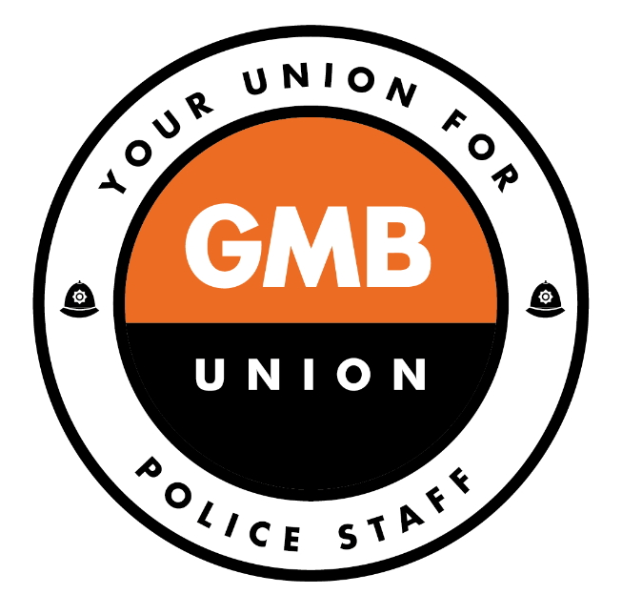

**Updated Contact details for GMB members.**

For GMB related messages or for assistance,

Email ***branch@gmbwestyorkshirepolice.org.uk***

GMB Branch Website:[***www.gmbwestyorkshirepolice.org.uk***](http://www.gmbwestyorkshirepolice.org.uk)

**Your branch secretary is Paul Rhodes who is based at**

8 Laburnum Road, Wakefield, WF2 7UA

22338

01924 292338

Mob 07981 065667

[paul.rhodes@westyorkshire.pnn.police.uk](mailto:paul.rhodes@westyorkshire.pnn.police.uk) WYP email address

[paul.rhodes@gmbwestyorkshirepolice.org.uk](mailto:paul.rhodes@gmbwestyorkshirepolice.org.uk) for GMB members

**Your branch president is Jim Wilson who can be contacted on** [**james.wilson@gmbwestyorkshirepolice.org.uk**](mailto:james.wilson@gmbwestyorkshirepolice.org.uk)

**Mob 07449540170**

**Call for legal advice** - If between hours 8am- 7pm you can call: Unionline on 0300 333 0303 Blackfords LLP are available 24 hours a day to assist in any emergency situation.

We can be contacted either through the Union Representative or directly via the 24 hour Unionline number.

If calling Blackfords direct, Unionline will need to be notified retrospectively so as to log the members details on their system so the relevant Region is aware of the position.

The Blackfords telephone numbers are: (t) 020 3427 3343 – office hours 9am – 5pm. 24 hour No's: Gary Rubin: 07748647697, Jennifer Richardson 07733103569, Jo Kaucher: 07766838035